Study experiment
Experiment No 12: To study 4-bitALU using IC-74181.

Description:

ALU stands for the arithmetic and logical unit and is one of the important unit in almost all the calculating machine these days be it with the hand-held mobile, or computers. All the computational work in the system are carried out by this unit. The typical ALU sizes are: 4-bit ALU: ALU that processes two 4-bit numbers.8-bit ALU: ALU that processes two 8-bit numbers. Still in the latest systems ALU sizes are 16, 32, 64-bit etc.Figure-12.1 shows the block diagram of a typical ALU.
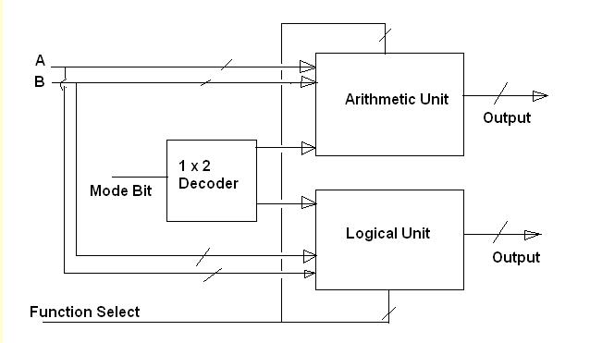

Figure-12.1: Block Diagram of ALU

In figure-12.1, the 1x2 selector on the left is as a mode selector to select one of the two units i.e. either the arithmetic unit or the logical unit. The function select lines are then used to select one of the many functions of arithmetic or the logical type.
MSI package for ALU:- IC 74181 a 4-bit Arithmetic and logical unit:
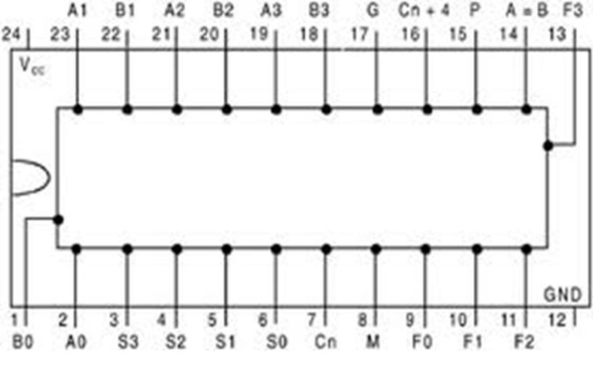

Figure-12.2: Pin Diagram of IC 74181 ALU

Internal Architecture of ALU IC 74181:
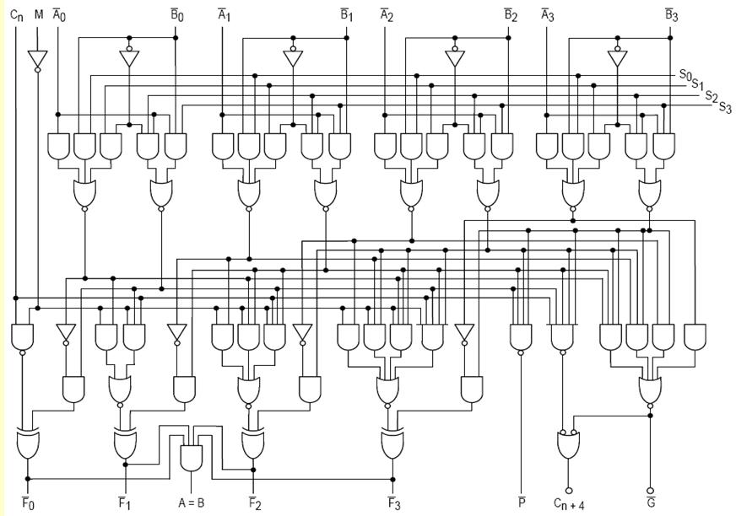

Figure-12.3: Internal Architecture of IC 74181 Function of ALU as seen from figure 12.3:
- The ALU has two 4-bit input lines A3-A0, B3-B0, and a 4-bit function select lines S3-S0.

- One mode select line „M‟ that is used to select ALU for either arithmetic or the logical function.

- It has four output lines f3-f0.
- Carry-in Cn is used in cascade mode.

- When the size is to be increased to 8-bit operations two 74181 can be cascaded and Cn+4 will be used as input to Cn line of next stage. The cascading is shown in figure-12.4.
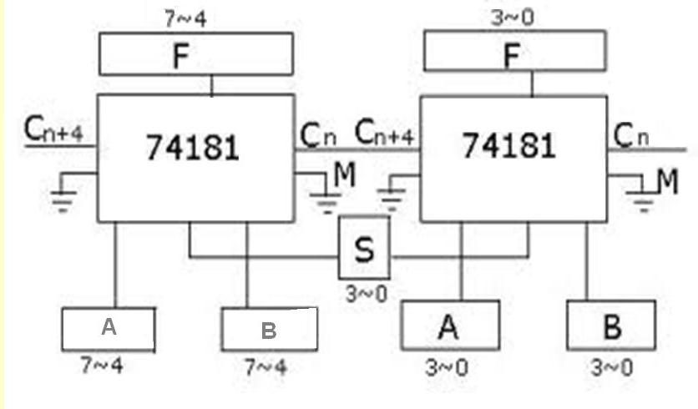

Figure-12.4: Cascading of ALU IC 74181 ALU

The function table of IC 74181 ALU is given in figure-12.5. It shows the functions selected depending on the Cn, M and S3-S0 lines.
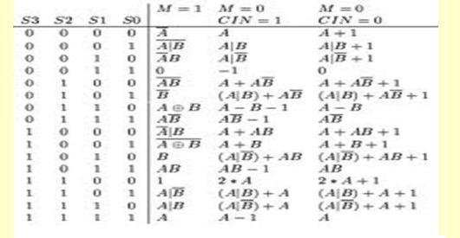

Figure-12.5: Function Table

Equipment Required:
IC 74181 , LEDs, Power Supply, CRO, Multimeter

Circuit diagram:

LEDs are connected at the input A and B lines and the select lines to indicate the value of the inputs A and B. The LEDs at the select lines are used to specify the function of the ALU. The LEDs at the output are used to test and verify the output. The whole implementation is shown in figure 12.6 is
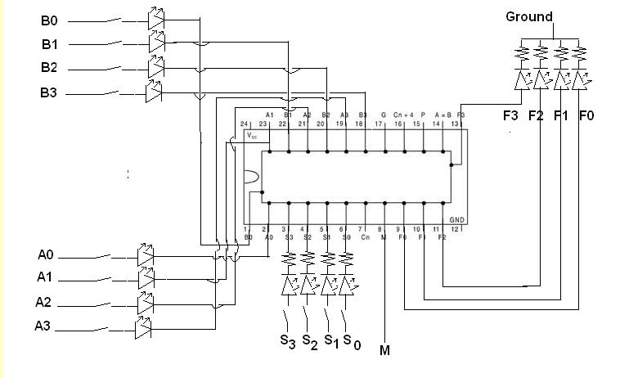

Figure-12.6: implementation of ALU with IC 74181

Procedure:
- Keep the datasheet of IC 74181 ready.
- Insert the IC on the Breadboard.
- Make connections as shown in figure-12.6
- Verify the connections

Result:

The above circuit when connected to power supply gives correct result as per the function table.

